Assignment 5

1. Write a shell program to calculate the factorial of a number.

2. Write a shell menu driven program to do the following: a. Display the current working directory.

b. Check whether an input number is even or odd.

c. Display the number of counts of all the files in the directory. d. Print the long listing of all the files.

3. Write a shell program to display all the prime numbers between 1 to 100 using while loop.

4. Write a menu program to find out whether a given letter is vowel or not.

5. Write a shell script which will generate the output as follows:

\*

\* \*

\* \* \*

\* \* \* \*

6. Write a shell script that computes the gross salary of a employee according to the following rules:  i)If basic salary is < 1500 then HRA =10% of the basic and DA =90% of the basic.  ii)If basic salary is >=1500 then HRA =Rs500 and DA=98% of the basic.  The basic salary is entered interactively through the key board.

Answers :

1.

Code :  
  
read -p"Enter number:" num

factorial=1

for i in $(seq 1 $num);

do factorial=$(($factorial\*$i))

done

echo "Factorial of $num is $factorial"

Output :

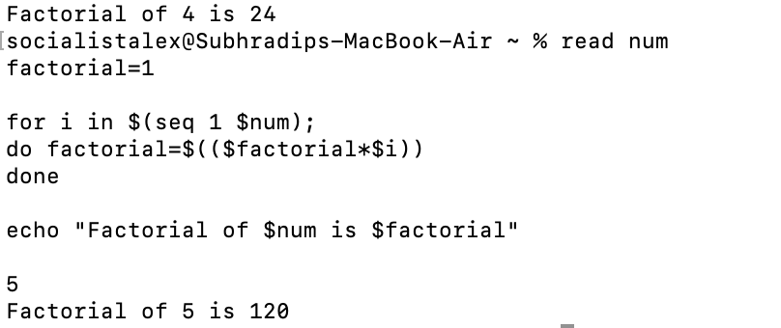

2.  
Code :  
  
while :

do

echo "1. Display the current working directory."

echo "2. Check Whether an input number is even or odd."

echo "3. Display the number of counts of all files in the directory."

echo "4. Print the long listing of files."

echo "5. Quit"

echo "Enter your choice:"

read choice

case $choice in

1)

pwd

;;

2)

echo "Enter number:"

read num

if [[ $(($num%2)) == 1 ]]

then

echo "$num is Odd"

else

echo "$num is Even"

fi

;;

3)

temp=`ls -l | grep -cv ^d`

echo "Files Count: $(( $temp-1 ))"

;;

4)

ls -l

;;

5)

exit 1

;;

esac

done

Output :

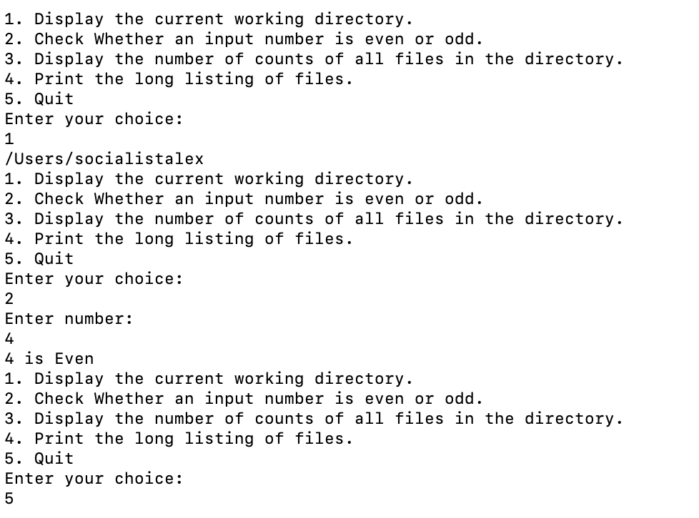

3.   
Code:  
  
for((i=1;i<100;i++));

do

    flag=0

    for((j=2;j<=$((i/2));j++));

    do

        if [ $((i % j)) == 0 ]

        then

            flag=1

        fi

    done

    if [ $flag == 0 ]

    then

        echo $i

    fi  
  
Output :  
  
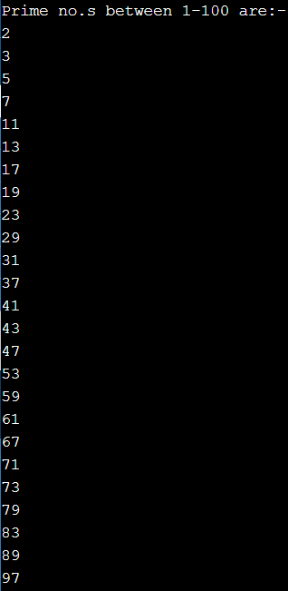

4.  
Code :  
echo "Enter character:"

read char

if [[ $char == [AEIOUaeiou] ]];

then

echo "$char is Vowel"

else

echo "$char is Consonant"

fi

Output :



5:  
Code :  
for((i=1;i<=4;i++));

do

for((j=1;j<=i;j++));

do

printf "\*"

done

printf "\n"

done  
  
Output :

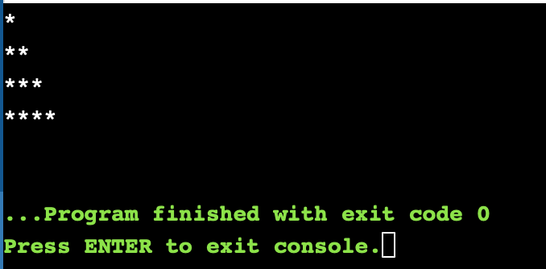

6.  
Code :

read -p"Enter basic salary: " bs

if [ $bs -lt 1500 ]

then

hra=$((bs\*(10/100)))

da=$((bs\*(90/100)))

gs=$((bs+hra+da))

fi

if [ $bs -ge 1500 ]

then

hra=500

da=$((bs\*(98/100)))

gs=$((bs+hra+da))

fi

echo "Gross Salary: $gs"  
  
Output :  
